System Architecture

Purpose
This document describes the overall architecture of the FPGA-Based Traffic Light Controller with Emergency Vehicle Priority. It explains how the modules communicate and how data flows through the system.

Overall Architecture
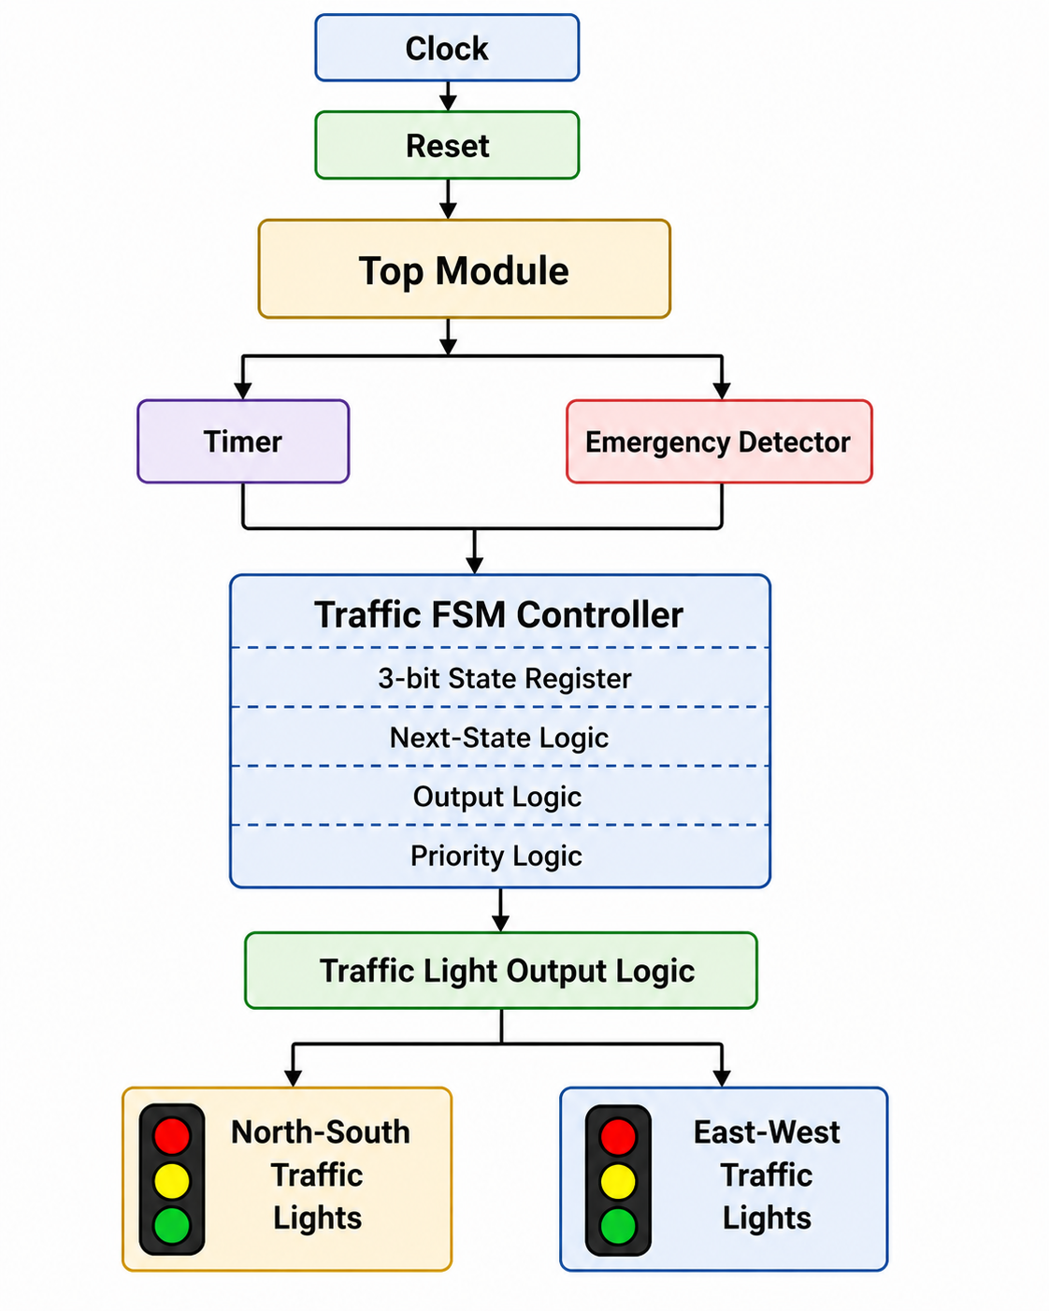

Module Description
Module | Inputs | Function
Top Module | clk, rst, emergency_ns, emergency_ew | Connects all submodules.
Timer | clk, rst | Generates timer_done for FSM transitions.
Traffic FSM | timer_done, emergency inputs | Controls state transitions and traffic lights.
Output Logic | Current state | Drives NS/EW LEDs.

System Data Flow
- Clock drives the Timer and FSM.
- Timer generates timer_done after the configured interval.
- Emergency inputs are continuously monitored.
- FSM determines the next state based on timer_done and emergency signals.
- Output logic activates the correct Red, Yellow, and Green LEDs.
- The process repeats every clock cycle.

Design Advantages
- Modular architecture for easier debugging and maintenance.
- Emergency handling separated from timing logic.
- Reusable Timer and FSM modules.
- Suitable for FPGA implementation and simulation.
- Easy to extend with pedestrian signals or adaptive timing.

Future Expansion
Additional modules such as vehicle density sensors, pedestrian crossing buttons, IoT connectivity, and adaptive traffic algorithms can be integrated without changing the overall architecture.

